Biographies

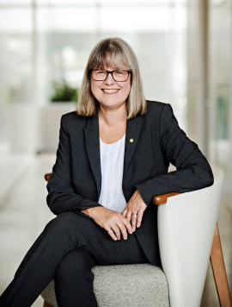
Donna Strickland is a professor in the Department of Physics and Astronomy at the University of Waterloo and is one of the recipients of the Nobel Prize in Physics 2018 for developing chirped pulse amplification with Gérard Mourou. Strickland was a research associate at the National Research Council Canada, a physicist at Lawrence Livermore National Laboratory and a member of technical staff at Princeton University. In 1997, she joined the University of Waterloo, where her ultrafast laser group develops high-intensity laser systems for nonlinear optics investigations. She is a recipient of a Sloan Research Fellowship, a Premier’s Research Excellence Award and a Cottrell Scholar Award. She served as the president of the Optical Society (OSA) in 2013 and is a fellow of OSA, the Royal Society of Canada, and SPIE.

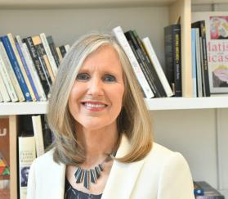
Carmen S. Menoni is University Distinguished Professor in the Department of Electrical and Computer Engineering at Colorado State University. Prof. Menoni’s expertise is in optical and material science. Her research focuses on the development of novel interference coating architectures for power scaling of mid-infrared lasers. She is also investigating fundamental mechanisms in amorphous oxides for low mechanical loss interference coatings for gravitational wave interferometers. Prof. Menoni is Fellow of the Institute of Electrical and Electronic Engineers (IEEE), the Optical Society of America (OSA), the American Physical Society (APS), the American Association for the Advancement of Science (AAAS), and SPIE.

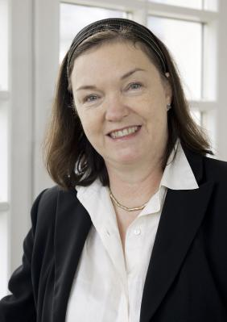
Johanna Stachel studied chemistry and physics at the University of Mainz and the ETH Zuerich. Since 1996 she has a chair a professor of experimental physics at Heidelberg University. She was the first female president of the 65,000 member German Physical Society 2012-2014. Scientifically, Stachel is exploring the Quark-Gluon Plasma, a phase of strongly interacting matter that existed in the early universe and can be created in the laboratory in collisions of highly energetic nuclei. She had an important role in the construction of the ALICE experiment at the LHC and serves in important managing functions. She also made seminal contributions to the phenomenology of this field.

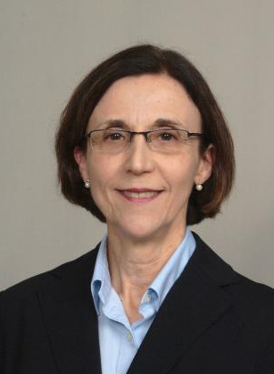
Leda Lunardi has been a professor since 2003 at the Electrical and Computer Engineering Department at North Carolina State University in Raleigh, NC. Her research areas are in fabrication and modeling of electronic and optoelectronic devices, and microelectromechanical devices. Before joining academia, she spent several years doing R&D at AT&T (then Bell Labs), and JDS Uniphase. In addition to her research, Dr. Lunardi has managed several NSF grants for STEM research and education to encourage women and underrepresented minority students to graduate in engineering and science and pursue graduate degrees. She has authored and co-authored more than 100 publications and conference proceedings, been granted 5 patents, and given invited talks, plenary addresses, and short courses at conferences. She is an IEEEE Fellow and co-shared the IEEEE Photonics Society Engineering Achievement Award.
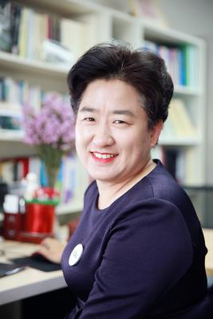
Haixia(Alice) Zhang, Professor, Institute of Microelectronics, Peking University. Dr. Zhang is active in the field of micro and nanotechnologies with a focus on micro energy devices and smart system. She is Editorial board member of IEEE-JMEMS, IEEE-TANO, Microsystems & Nanoengineering, IET MNL, etc. She is co-author of 250 peer-reviewed scientific publications and 9 books/book chapters, co-invented 42 patents (include 5 US patents). She served on the program committees of numbers conference, such as IEEE NEMS, IEEE Nano, and MNE conferences. She is the founder of iCANX Talks.
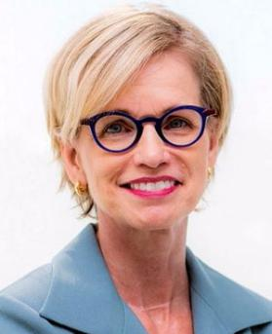
Liz Rogan has been at OSA for almost 30 years in positions initially focused on operations. Beginning in 2002, she was honored with the role of Chief Executive Officer (CEO) of OSA and The OSA Foundation. In 2018, Liz was recognized as a Foreign Fellow of the Chinese Optical Society as part of their first class of foreign fellows. This is the highest honor to those who have made outstanding contributions to the development of optics and photonics science and technology in China. In 2019, Liz was recognized as an OSA Fellow for outstanding long-term management at OSA and leadership across the optics and photonics community.

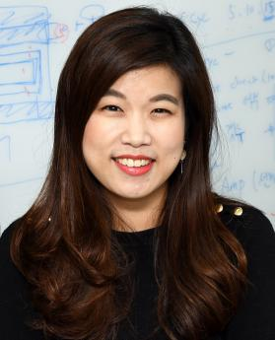
Miso Kim is an assistant professor of the School of Advanced Materials Science and Engineering (AMSE) at Sungkyunkwan University (SKKU). She received her M.S. (2007) and Ph.D. degrees (2012) in Materials Science and Engineering from the Massachusetts Institute of Technology (MIT). She worked in Korea Research Institute of Standards and Science (KRISS) as a senior research scientist from 2012 till Feb. 2021. She recently joined the School of AMSE at SKKU in February 2021 as a faculty member. Her primary research interests cover analytical modeling, design, and experimental characterization of piezoelectric materials and mechanical metamaterials for energy harvesting and sensing.

